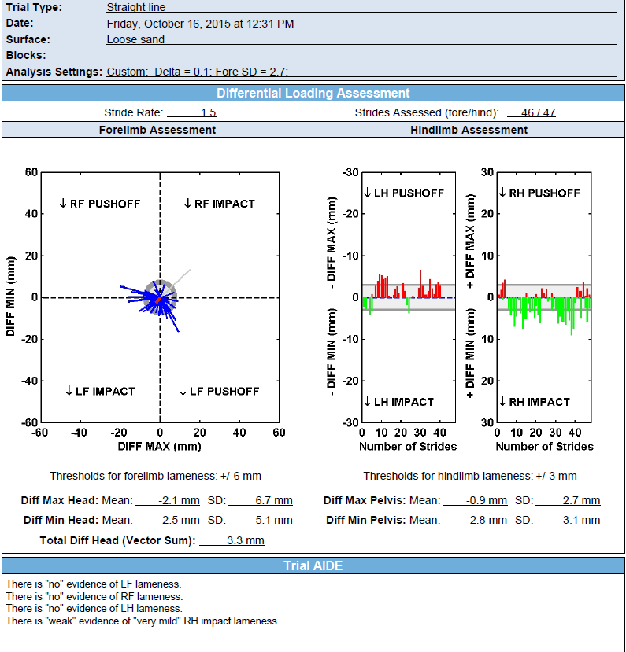

Normal

This is a great example of a normal reading. A few steps are outside of the thresholds, but they are not consistent. There is a very mild right hind impact type asymmetry, however it is still within the normal threshold of acceptable pelvic movement.